**DATABASE FOR BALTIMORE CITY COMMUNITY COLLEGE**

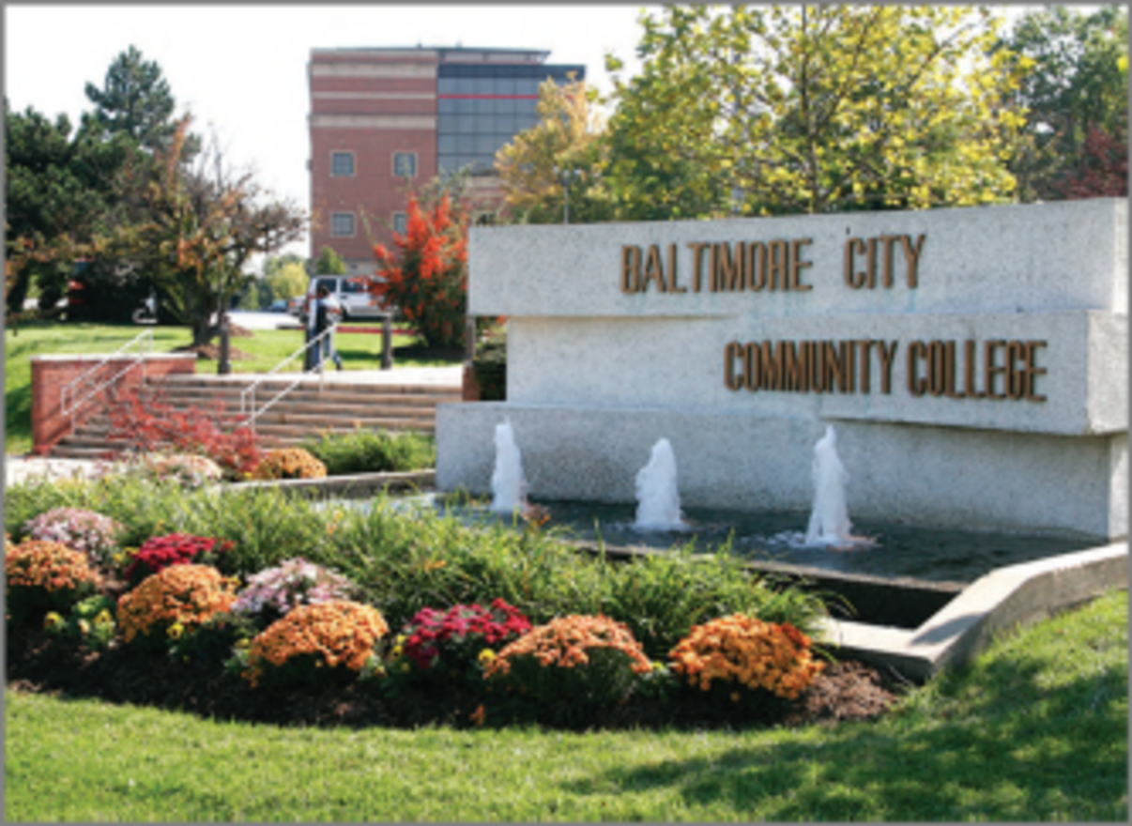

**DATABASE MANAGEMENT SYSTEMS PROJECT PREPARED BY:**

Dalton Brown | Matt Clark | Jacob Della | Christian Sauls

Towson University

Fall 2020

Table of Contents

Team Members 2

Signature of Interviewee 2

Introduction of BCCC Database 3

BCCC Business Process 3

User Requirements 4

Entity Relationship Diagram (ERD) 6

Assumptions 6

Schema 7

Task List 8

Meeting Log 9

# Team Members

* Dalton Brown
* Matt Clark
* Jacob Della
* Christian Sauls

# Signature of Interviewee

# Introduction of BCCC Database

Baltimore City Community College (BCCC) is located in the heart of Baltimore, and boasts of an enrollment that averages more than 5,000 students. They offer continuing educations programs, associate degree-granting programs, and IT certification-granting programs. BCCC’s objectives are to identify training needs for Baltimore residents and to offer quality education services for those needed areas. BCCC also has many classes that are funded through grants, meaning that having access to information to make it easier to apply for grants and for reporting activity to maintain the grants is paramount for their success.

Currently, BCCC keeps their records in disparate excel spreadsheets, for dozens of classes and hundreds of students. One can imagine the pain of keeping track of all this information and trying to form reports from it. The department’s decentralized approach to knowledge management has resulted in a much higher level of effort to collect, update, and find information related to the day-to-day functioning of their programs. Compiling information to complete specific reports may sometimes take multiple days to track down all of the required information.

If the department were to obtain and employ a centralized database for record keeping, they could gain administrative and operational efficiencies that would allow them to focus more time on servicing their core competencies and goals versus chasing paper and disparate spreadsheets.

The development of a database project for Baltimore City Community College began in September of 2020. A team of four students is working on this project. The database will be made in MySQL and the user interface to the database will be created using Java Swing. This project is being done for the Database Management Systems course (COSC 457) at Towson University, and will incorporate the knowledge that the students have obtained and will be learning throughout this Fall 2020 semester.

# BCCC Business Process

The Department off Workforce Development and Continuing Education at BCCC offers a Cybersecurity training program to the citizens of Baltimore city. The program consists of four classes:

* Essentials skills
* A+ certification
* Network+ certification
* Security+ certification

The applicants go through a testing process upon hearing about the program to determine their cognitive aptitude. That data is then sorted by the director and the coordinator to determine which students will be accepted into the program. Once the student is accepted, they are registered for the “Essential skills” class which lasts approximately four weeks. Information gathered from the student includes educational records, date of birth, social security number, and proof of residence to begin their student profile.

During their first course, students are taught various skills that help them discover their own potential as well as prepare them for the interview process when looking for employment. When the student successfully completes the course, they are then registered for the first available “A+ certification” course. Their information is collected yet again to verify and confirm their residential status and general information such as name, address, phone number, and current email address.

In order to follow the grant guidelines that support the program, the attendance and grades of each student are kept to track their progress and sincerity about completing the program. Attendance information is currently submitted daily via sign-in sheet which is then converted to data in an excel spreadsheet as a form of record keeping. Grades are submitted weekly via individual class excel spreadsheets. The collected data is stored in both hard copy and electronic copies. This process is repeated for all the classes currently running.

There are 14 classes that meet twice weekly, and two classes that meet once a week. All students are encouraged to attempt the certification exam upon completion of each course, and if the student passes, that certificate is added to their file. Program enrollment varies from 60 to 100+ students.

# User Requirements

**Process Modeling Requirements**

The Workforce Development Department keeps track of **Student** data. Each student's full name, student identification number, home phone number, work phone number, student email address, current residence address, permanent residence address, date of birth, sex, degree program, citizenship status, social security number, and grant authorization details are collected during the registration process. Students can **register**, **drop** and/or **withdraw** a course.

Each **Course** has an identification number, course title, begin date, end date, course description, offering department, and grade received. If a Student withdraws from the course prior to the first class meeting or the college itself cancels the course, a 100% refund is made. Refunds will not be granted for classes that are dropped after the first class date.

Each **Department** is described by department name, department code, office number, office phone number, and advisor.

For **Instructor**, the college tracks the advisor’s name, ID, and the department number to which he/she is assigned. An Instructor may advise any number of students but each student has just one advisor.

Administrators issue the **Identification Card**. To issue an Identification Card, particular details are necessary, such as name, date of birth, sex, status (student, staff or visitor), address, identification number, date the identification was issued and the identification expiration date.

**Data Modeling Requirements**

Allow users to input information for the Department, Students, Staff, Courses, Programs, and Grade records. A few examples of some user requirements that this database will meet are listed as the following:

1. Allow user to update all the above information.
2. Allow user to access specific information for students, staff, courses, etc.
3. Allow user to generate a list of the number of students currently assigned under a specific department.
4. Allow user to generate a list of staff assigned to a specific course.
5. Allow user to generate a list of courses offered by a program during a specific semester.
6. Allow user to retrieve grade records for a specific course.
7. Allow user to retrieve grade records for each student.
8. Allow user to retrieve a list of visitors on a specific day.
9. Allow user to separate information according to identification status (student, staff, or visitor).
10. Allow user to verify all students have an advisor.

**Expected Database Queries**

1. List the names of the courses offered by a specific program.
2. List what courses are offered in a specific department during a specific semester.
3. List the first and last names of staff that teach a course in a specific program.
4. List the first and last names of staff that are also an advisor.
5. List the first and last names of students who has a specific staff member as an advisor.
6. Retrieve how many students withdrew/dropped a specific course during a specific semester.
7. Generate a list of professors who have taught at Baltimore City Community College for more than or equal to five years as of a specific semester.
8. List all of the first and last names of students enrolled in a specific program who are female.
9. Find the name of the student who has a specific ID no.
10. List the grade records all of the courses during a specific semester for a particular student.

# Entity Relationship Diagram (ERD)

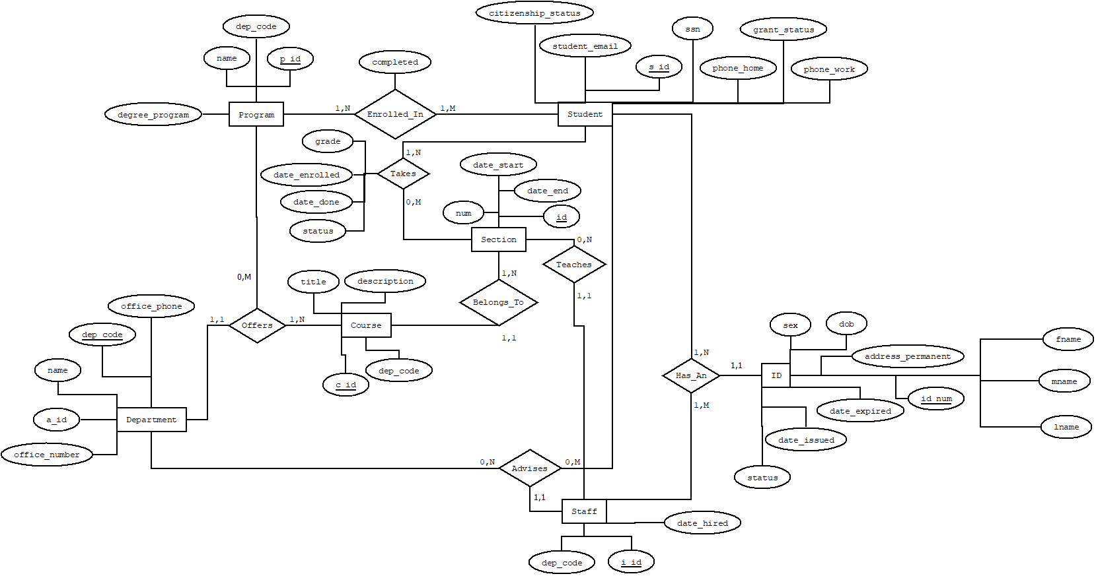

# Assumptions

* There is at least one Student and one Staff, one Course, and one Department.
* A Student can enroll in a maximum of one Program.
* A Student can take as many Courses as they want, or no Courses at all.

A Staff can advise any number of Departments.

* A Staff can teach any number of Courses.
* Every Course belongs to one Department.
* A Course has at least one instructor (Staff).
* Departments and Programs offer at least one Course.

# Schema

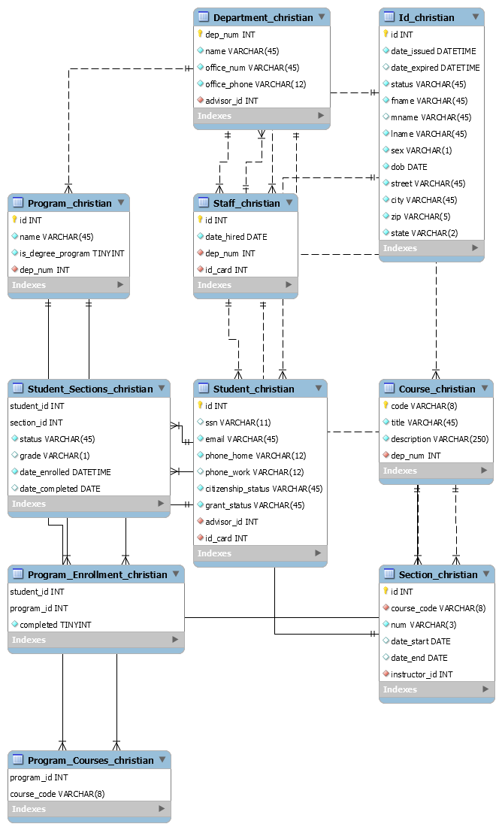

# Task List

|  |  |  |  |  |
| --- | --- | --- | --- | --- |
| **Task Name** | **Duration** | **Start Date** | **Finish Date** | **Member Names** |
| Analyze requirements | 1 day | 09/24/2020 | 09/24/2020 | All |
| Draw ERD | 1 day | 10/05/2020 | 10/05/2020 | Christian Sauls |
| Create schema | 2 days | 10/05/2020 | 10/06/2020 | Jacob Della |
| Finalize project report 1 | 2 days | 10/05/2020 | 10/06/2020 | Matthew Clark  Christian Sauls |
| Submit project report 1 | 1 day | 10/06/2020 | 10/06/2020 | Christian Sauls |
| Create database in MySQL | 3 day | 10/09/2020 | 10/12/2020 | Christian Sauls, Jacob Della |
| Create user interface | 4 day | 11/12/2020 | 11/16/2020 | Christian Sauls, Jacob Della |
| Test database and interface | 5 day | 11/20/2020 | 11/25/2020 | Jacob Della, Christian Sauls, Matt Clark |
| Finalize project | 2 day | 11/27/2020 | 11/29/2020 | All |
| Submit project | 2 day | 11/29/2020 | 11/31/2020 | Jacob Della |
| Prepare PowerPoint | 1 day | 11/31/2020 | 12/1/2020 | Jacob Della |

# Meeting Log

|  |  |  |
| --- | --- | --- |
| **Time** | **Place** | **Contributions** |
| 10/05/2020 @ 8:00 PM | Online | Matthew Clark and Christian Sauls: Report 1  Christian Sauls: ERD  Jacob Della: Schema draft |
| 10/12/2020 @ 5:00 PM | Online | Christian Sauls: ERD  Jacob Della: Schema draft |
| 11/12/2020 @ 5:00 PM | Online | Matthew Clark: Queries  Jacob Della: Schema Revisions |
| 11/15/2020 @ 5:00 PM | Online | Christian Sauls: Schema Revisions  Jacob Della: Boiler Plate Code Python |
| 11/17/2020 @ 4:00 PM | Online | Christian Sauls: Schema Revisions  Jacob Della: Boiler Plate Code Python |
| 11/19/2020 @ 4:00 PM | Online | Christian Sauls: Finalized Python Code  Jacob Della: Report 2 Additions |
| 11/29/2020 @ 4:00 PM | Online | Christian Sauls: Report 2 Suggestions  Jacob Della: Report Additions |